SEO Metadata
- Focus Keyword: best digital marketing agency in Bangalore
- Meta Title: Best Digital Marketing Agency in Bangalore (2026 Guide) | Brewing Ideaz
- Meta Description: Looking for the best digital marketing agency in Bangalore? Learn what to evaluate — strategy, channels, reporting, pricing & red flags — before you hire.
- URL Slug: /best-digital-marketing-agency-in-bangalore

Secondary Keywords
- digital marketing agency in Bangalore
- best digital marketing company in Bangalore
- digital marketing services in Bangalore
- online marketing agency Bangalore
- SEO agency in Bangalore
- performance marketing agency Bangalore
- social media marketing agency Bangalore
- digital marketing company Bangalore
- digital marketing experts in Bangalore
- Brewing Ideaz Bangalore

Internal Linking Suggestions
- /services/ or /digital-marketing/
- /contact-us/
- /portfolio/ or /case-studies/

Best Digital Marketing Agency in Bangalore: A Practical Guide to Choosing the Right Partner
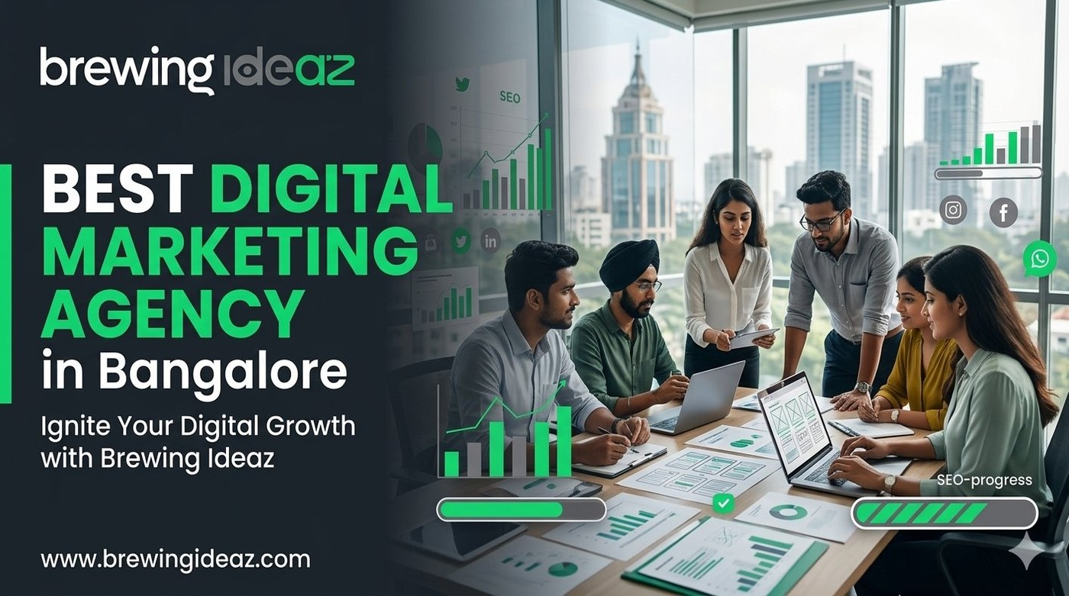
Bangalore’s startup and enterprise scene is intensely competitive. Hundreds of agencies claim to be the “best digital marketing agency in Bangalore,” yet results vary widely. Choosing the wrong partner can waste budget and months of momentum. This guide gives you a clear framework to evaluate agencies so you can select one that actually drives growth.

What “Best” Means in Digital Marketing
A strong digital marketing agency does more than run ads or post on social media. It should understand your business goals, map the full customer journey, and build an integrated strategy across SEO, paid media, content, social, email and conversion optimisation. The best agencies measure what matters — pipeline, revenue, CAC, LTV — not just vanity metrics.
Fit matters as much as capability. An agency excellent at performance marketing for D2C brands may not be ideal for a B2B SaaS company, and vice versa.

Key Factors to Evaluate Before Hiring

Strategic depth
Do they start with discovery, audience research and goal setting, or jump straight into channel tactics?

Channel expertise relevant to you
Ask for case studies in SEO, Google Ads, Meta, LinkedIn, content or the mix your business needs.

Transparent reporting
You should receive clear dashboards and regular reviews that connect activity to business outcomes.

Team structure
Who will actually work on your account — senior strategists or mostly juniors?

Pricing model clarity
Understand retainers, project fees or performance-based models and what is included.

Cultural fit and communication
Bangalore agencies that work well with fast-moving startups usually offer Slack access, weekly calls and proactive recommendations.

Why a Bangalore-Based Digital Marketing Agency Has Advantages
Local agencies understand the city’s startup ecosystem, investor expectations and the mix of B2B and B2C audiences. Real-time collaboration is easier, and many have experience scaling both early-stage companies and more mature brands in the same market.

Questions to Ask Before You Hire
- Can you walk me through your discovery and strategy process?
- Do you have recent case studies in my industry or similar growth stage?
- How do you measure and report success — what KPIs do you prioritise?
- Who will be the day-to-day team on my account?
- What does a typical first 90 days look like?

Red Flags to Watch For
Be wary of agencies that guarantee #1 rankings, promise unrealistic ROI in a few weeks, refuse to share client references, or cannot clearly explain their process and pricing. Overly aggressive sales tactics or opaque contracts are also warning signs.

Final Thoughts
The best digital marketing agency in Bangalore for your company is the one that understands your goals, brings relevant expertise, reports honestly, and works as an extension of your team.

Ready to Discuss Your Growth Goals?
Brewing Ideaz is a digital agency with its corporate office in Bengaluru (Sarjapur – Marathahalli Road) and a branch in Kolkata.
Call or WhatsApp: (+91) 62915 47048 Email: info@brewingideaz.com
We’re happy to share how we approach digital strategy for growing businesses.

30 Frequently Asked Questions About Digital Marketing Agency in Bangalore
- What is a digital marketing agency? A digital marketing agency helps businesses promote their products or services through online channels such as search engines, social media, paid advertising, email, and content marketing.
- How do I choose the best digital marketing agency in Bangalore? Evaluate the agency’s strategy, relevant experience, service offerings, reporting process, pricing, communication, and ability to understand your business goals.
- What services does a digital marketing agency provide? Common services include SEO, Google Ads, social media marketing, content marketing, email marketing, performance marketing, and conversion rate optimisation.
- How much does a digital marketing agency in Bangalore charge? Pricing depends on the services required, campaign complexity, business goals, and agency experience.
- Why should I hire a digital marketing agency? An agency can provide specialised expertise, help execute marketing campaigns, track performance, and support your business’s online growth.
- Is a digital marketing agency suitable for startups? Yes. Startups may use agencies to build brand awareness, reach target audiences, generate leads, and develop strategies within budget.
- What is the difference between SEO and digital marketing? SEO focuses on improving a website’s visibility in organic search results. Digital marketing is a broader field that includes SEO, paid advertising, social media, email, and more.
- How long does digital marketing take to show results? The timeline depends on the channel, competition, budget, and strategy.
- What is performance marketing? A results-oriented approach measured using specific actions or outcomes, such as clicks, leads, purchases, or conversions.
- What is included in a digital marketing strategy? Business objectives, audience research, channel selection, content planning, budgets, campaign execution, and performance measurement.
- What is local digital marketing? Helping businesses reach customers in a specific geographic area through local SEO, business listings, location-based advertising, and relevant content.
- Can digital marketing help small businesses? Yes, it can improve online visibility, connect with potential customers, and generate enquiries.
- What is the role of SEO in digital marketing? SEO helps improve a website’s visibility in organic search results.
- What is social media marketing? Using platforms such as Instagram, Facebook, LinkedIn, and others to share content, engage audiences, and promote a business.
- What is content marketing? Creating and distributing useful, relevant content to attract and engage a target audience.
- How do I measure the success of a digital marketing campaign? Qualified leads, conversions, revenue, CAC, ROAS, and relevant engagement metrics.
- What is customer acquisition cost (CAC)? The amount a business spends to acquire a new customer, including relevant marketing and sales expenses.
- What is lifetime value (LTV)? An estimate of the total revenue or value a business expects from a customer over the relationship.
- What is conversion rate optimisation? Improving a website or landing page to increase the percentage of visitors who complete a desired action.
- What should I include in a digital marketing agency contract? Services, deliverables, fees, timelines, reporting, account access, responsibilities, data ownership, and cancellation terms.
- How often should a digital marketing agency provide reports? Depends on the campaign; many businesses use monthly reports alongside more frequent updates for active campaigns.
- What is Google Ads? An online advertising platform that allows businesses to display paid ads across eligible Google properties and partner placements.
- What is the difference between organic and paid marketing? Organic marketing attracts audiences without paying per placement; paid marketing uses budgets to reach audiences through paid placements.
- Can a digital marketing agency help with lead generation? Yes, using SEO, paid advertising, landing pages, content, and other channels.
- What is a digital marketing audit? An evaluation of a business’s online marketing activities, including website, SEO, advertising, content, and analytics.
- Should I choose a specialised agency or a full-service agency? Depends on your business needs, internal resources, and campaign requirements.
- What are common mistakes businesses make when hiring a digital marketing agency? Choosing solely based on price, failing to define goals, overlooking contract terms, ignoring reporting quality, and not checking relevant experience.
- Does a digital marketing agency guarantee results? No agency can reliably guarantee specific outcomes such as first-place rankings or a fixed ROI.
- What should I prepare before contacting a digital marketing agency? Business goals, target audience, current marketing performance, budget range, required services, and relevant campaign information.
- How can I contact Brewing Ideaz for digital marketing services in Bangalore? You can contact Brewing Ideaz by calling or WhatsApping +91 62915 47048 or emailing info@brewingideaz.com.

